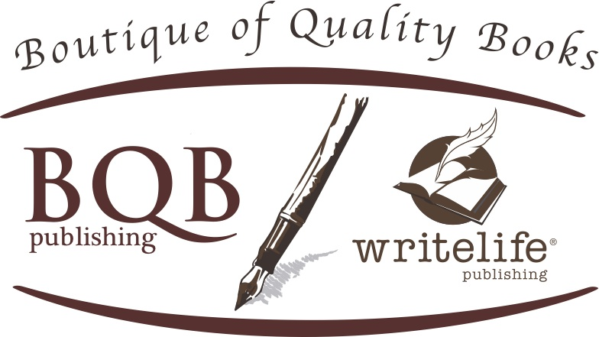
FOR IMMEDIATE RELEASE
Media Contact:
Julie Bromley
julie@bqbpublishing.com

March Madness, The Final Four, love of college sports, and human greed are tied together into this suspenseful, action packed novel.

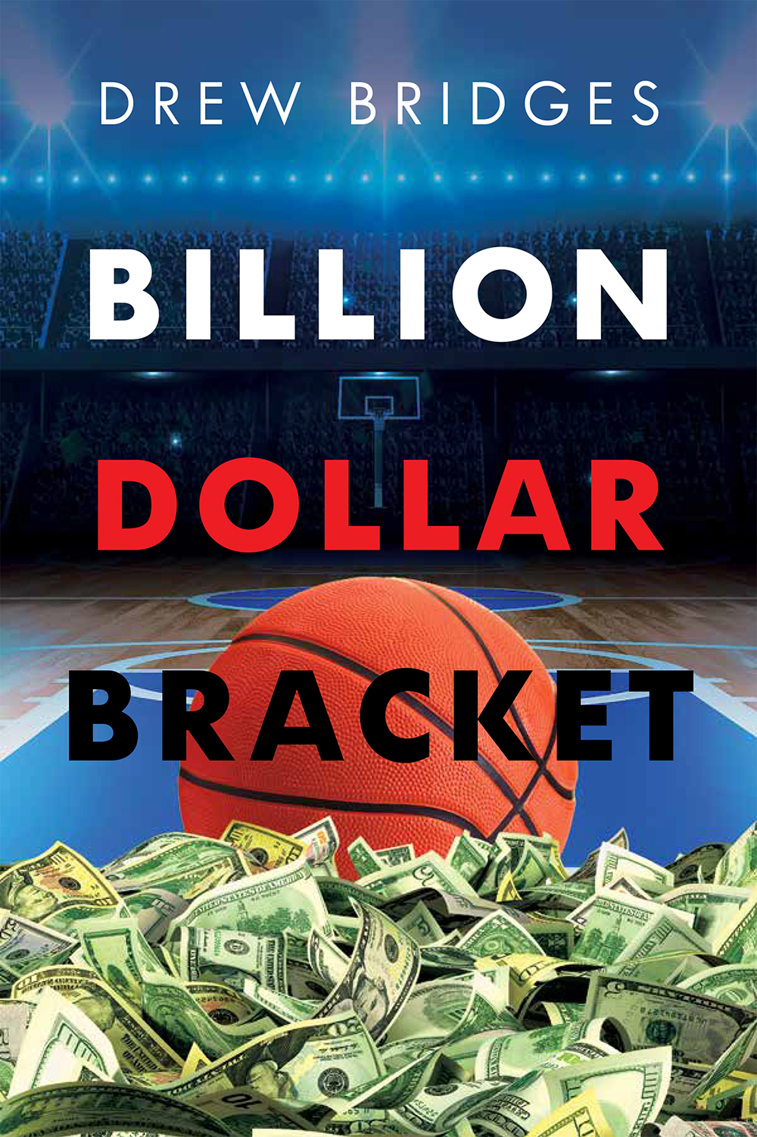

Author Drew Bridge’s knowledge and love of basketball are woven into a suspenseful novel that even non-sports fans will love.
During March of each year, seventy million people fill out the National Collegiate Athletic Association basketball tournament bracket, either in national contests or office pools. The goal is to predict all the winners for a tournament of 68 teams. The odds against perfection are astronomical. A small group of social media marketers, led by mathematician Sinclair Dane, see this annual quest as an under-appreciated opportunity to make money on sports betting. For a two-dollar entry fee, they offer one billion dollars for anyone who can predict the winners of all the games. Their financial hopes are initially greatly exceeded as the contest goes global. Entry fees multiply their anticipated profit many times over.
But disaster looms when a math professor from a small university has a perfect bracket with just four teams remaining. The professor has his own troubles. The
NCAA opens an investigation into his use of the bracket contest to teach math concepts to a class that includes tournament athletes. As the "final four" approaches, Sinclair looks at the possibility of having to pay a billion dollars she does not have. The professor and his students may face charges of trying to influence the outcome of games.

ABOUT THE AUTHOR:

Drew Bridges is a retired psychiatrist who has restored himself to his default identity of "English major." His restoration included operating a bookstore for seven years in the town of Wake Forest, North Carolina, where he lives with his wife Lauren, a psychotherapist.

In Billion Dollar Bracket, he draws upon two lifelong passions, the world of college sports and the study of human psychology to create a story filled with suspense and controversy.

His previous novel, Family in the Mirror, was selected as Finalist in the 2017 Next Generation Indie Book Awards.

About Boutique of Quality Books Publishing Company, Inc.
Founded in August of 2010, Boutique of Quality Books Publishing was created to be “the writer’s publisher,” focusing on quality writing from new authors in both fiction and nonfiction genres. An independent publisher, Boutique of Quality Books, under its two imprints—BQB Publishing and WriteLife Publishing—combines the quality processes of traditional publishing with hands-on author involvement to bring today’s new writers and tomorrow’s best sellers into the hands of booksellers and the reading public. www.bqbpublishing.com www.writelife.com

All books published by Boutique of Quality Books Publishing Company, Inc., and its two imprints —BQB Publishing and WriteLife Publishing—are distributed by IPG www.ipgbooks.com

